Thirsty Work!

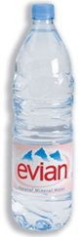

2 cartons of orange juice cost £1.26. How much would 3 cost?
3 bottles of mineral water cost £1.35. How much would 5 cost?
What would 5 cartons of orange and 4 bottles of mineral water cost altogether?

How much change would you receive from £10?

How many bottles of mineral water could you buy with £5?

