Pottering on

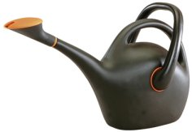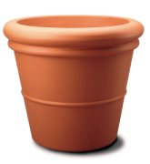

Mary buys a watering can and two flower pots.
She pays £4.30.

A watering can and one flower pot would cost £3.60.

How much will Eric pay for a watering can and three flower pots?

