Pottering on

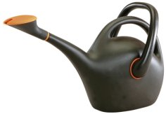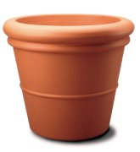

Mike buys a watering can and four flower pots.
He pays £5.75.

A watering can and one flower pot would cost £3.65.

How much will Tony pay for a watering can and three flower pots?

