Pottering on

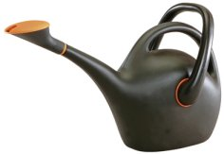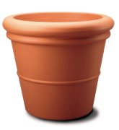

Amanda buys a watering can and a flower pot.
She pays £3.50.

A watering can costs £2.80.

How much will Stephen pay for a watering can and two flower pots?

