Squashmaking!

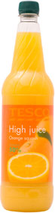

1 litre bottle of High Juice costs £1.29.
To make squash, it is diluted with water in a 1:4 ratio.
How much water is needed altogether?

How much squash can be made from the whole bottle?

Tom always takes a flask of squash when he goes out.
His flask holds 700ml.
How many flasks could be filled using 1 bottle of High Juice?

Tom has invited 35 people to his birthday party.
He reckons everyone is likely to drink 500ml of squash.
How many bottles of High Juice does he need to buy?

How much will that cost him?

