A dose of medicine

Jamie has a nasty cough so his mum buys some medicine.

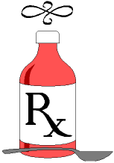

A bottle of cough medicine holds 300 ml.
How many 5 ml spoonfuls can she get from that?

Jamie has to take 2 spoonfuls 4 times a day.
How much medicine is that each day?

At that rate, how many days would the bottle last?
(There are 2 ways of working this out!)

Jamie takes his first dose on Wed 23rd March.
When would the bottle be finished?

