Lots of little legs!
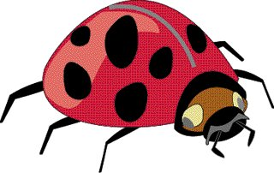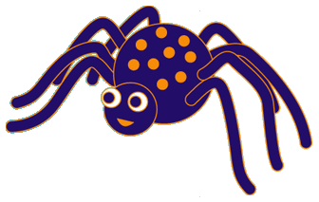

Key Stage 1 are investigating ladybirds, which have 6 legs, and spiders, which have 8 legs. They made a collection. Then they counted how many legs they could see. It took a long time!

Their total was 34 legs. How many ladybirds and spiders might they have collected?

