Ladybirds
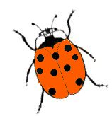
Mr Grubb's pot plant is the home of ladybirds. Some are 4-spotted ladybirds, the others are 9-spotted.

Altogether, they have 48 spots. How many 4-spotted and how many 9-spotted ladybirds could there be?

If they had 62 spots in total, how many 4-spotted and 9-spotted ladybirds could there be?

