Jam and honey

Some jars of jam and honey are in the cupboard.
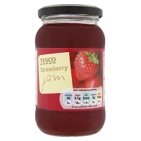

Three jars of honey weighs 750g.
A jar of jam and two jars of honey weighs 900g.

What does a jar of honey weigh?
What does a jar of jam weigh?

Which weighs more, and by how much:
3 jars of jam or 4 jars of honey?

