Jam and honey

Some jars of jam and honey are in the cupboard.
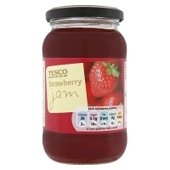

Three jars of honey weighs 750g.
One jar of jam and one of honey weighs 650g.

What does a jar of honey weigh?
What does a jar of jam weigh?

Which weighs more, and by how much:
3 jars of jam or 4 jars of honey?

