The Fruit Shop

Bananas cost 18p. Oranges cost 7p more.

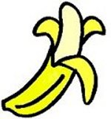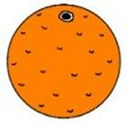

Arthur buys twice as many bananas as oranges. He gives the shopkeeper a £5 note and receives 73p change.

How many bananas did he buy?

How many oranges did he buy?

