The Fruit Shop

Bananas cost 18p. Oranges cost 7p more.


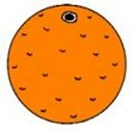

William buys 3 bananas for every 2 oranges.
He gives the shopkeeper £10 and receives £2.72 change.

How many bananas did he buy?

How many oranges did he buy?

