The Fruit Shop

Bananas cost 18p. Oranges cost 7p more.

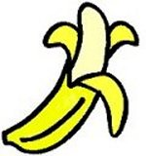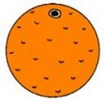

Harry buys twice as many bananas as oranges. His purchases cost £2.44.

How many bananas did he buy?

How many oranges did he buy?

