Dogwise…

Here are a Border Collie, a Jack Russell terrier, a German Shepherd dog and an English Springer Spaniel.

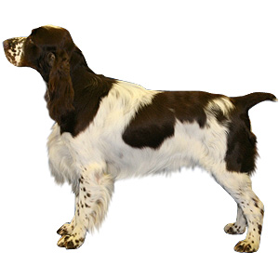

The Collie and the Jack Russell weigh 25kg.
The Jack Russell and the German Shepherd weigh 38kg.
The Collie and the German Shepherd weigh 45kg.
The Jack Russell and the Spaniel weigh 30kg.

How much does each dog weigh?

Border Collie

Jack Russell

German Shepherd

Springer Spaniel

How much more than the Collie does the heaviest dog weigh?

Do the two lightest dogs together weigh as much as the heaviest?

What is the difference between them?

