Citric Choices

In the superstore, an orange juice costs 45p and a Fruit Shoot costs 60p.
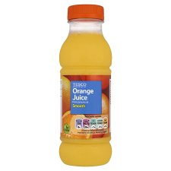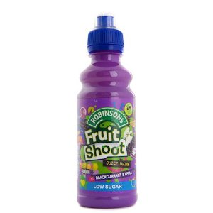

Daphne spends £2.40. What might she have bought?
(2 solutions)

Judith receives £2.30 change from a £5 note.
What might she have bought? (2 solutions)

A four-pack of orange juice costs £1.50.
How much will Chris save if he buys two four-packs instead of eight single bottles?

