The Choc Shop

The Choc Shop sells Dairy Milk, Mars bars and KitKats.

A Dairy Milk and Kit Kat costs 90p.
A Mars bar and Kit Kat costs 95p.
A Dairy Milk and Mars bar costs 85p.
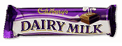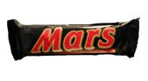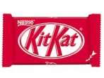

What does each item cost?

How much change would you receive from £5 if you buy 2 Mars bars, a Dairy Milk and 3 Kit Kats?

A Twix and 2 Mars bars costs £1.50. What would you pay for a Twix, 2 Dairy Milks and a Kit Kat?

