The Choc Shop

The Choc Shop sells Dairy Milk, Mars bars and KitKats.

A Dairy Milk and Kit Kat costs 90p.
A Mars bar and Kit Kat costs 95p.
A Dairy Milk and Mars bar costs 85p.
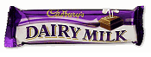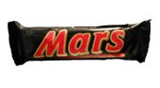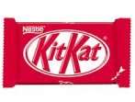

What does each item cost?

What would you pay for 2 Mars bars, a Dairy Milk and a Kit Kat?

