Serious about cereals

Muesli is sold in 750g boxes.
Porridge is sold in 500g boxes.
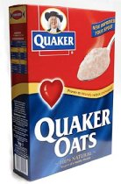

Mrs MacDougall buys 2.5 kg of cereals.
What 2 different combinations might she have bought?

Muesli costs £1.29 and porridge costs 95p.
Mrs Robertson buys a box of muesli and 2 boxes of porridge.
How much will she pay?

How much change would she get from £5?

