The Camping Trip

25 scouts go on a camping trip.
In the store room are 8 two-person tents and 5 four-person tents.

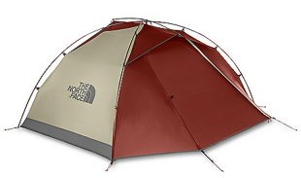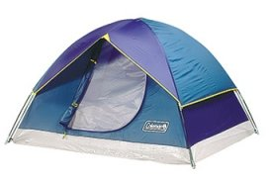

- What is the fewest number of tents needed for all the scouts?

- How many four-person tents would be used?

3. How many two-person tents would be used?

- Are there any spare places?
If so, how many?

