Cakes for sale!

Lily and Katie are helping on the PTFA cake stall.
The price of a chocolate cake is 75p.
The price of a fruit cake is 50p.
The price of a cream cake is 60p.

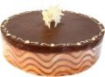

Lily’s first order adds up to £2.60.
What cakes might she have sold?

Katie’s first order totals £4.20.
What cakes could she have sold? (4 combinations)

