Badminton battles
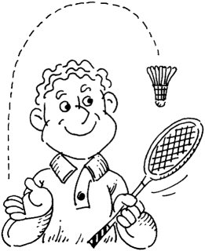

Adam, Beth, Charlie, David and Emma play a badminton competition between themselves. They have a ‘round robin’ where everyone plays everyone else once.

Make a list of who plays whom in each game:

How many games will they play altogether?

