The aviary

In the aviary there are twice as many parrots as owls.
There are 2 more owls than toucans.

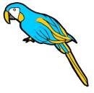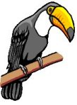

Altogether, there are 18 birds.

How many are owls?

How many are parrots?

How many are toucans?

