An average academy

There are 96 pupils at the Butterfly Academy.
They are taught in 4 classes called Red Admirals, Painted Ladies, Tortoiseshells and Peacocks.

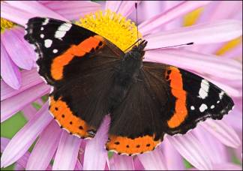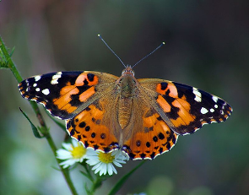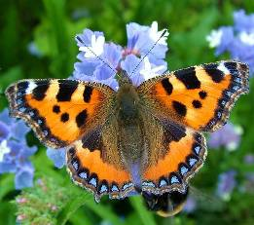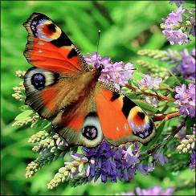

There are 24 pupils in the Red Admirals class.
There are 4 fewer Peacocks than Red Admirals.
There are 2 more Tortoiseshells than Painted Ladies.

1. How many pupils are in the Peacocks class?

2. How many are in the Painted Ladies?

3. How many are in the Tortoiseshells?

4. What fraction of the pupils are Red Admirals?

5. What fraction are Peacocks?

6. What is the mean class size?

7. What is the median class size?

8. What is the range of class sizes?

