Vegetable Variety

Grey Gables Hotel orders 60 kg of vegetables.

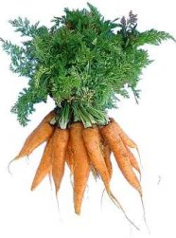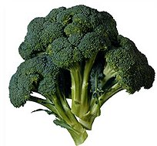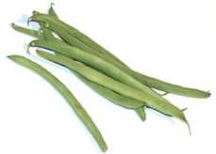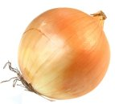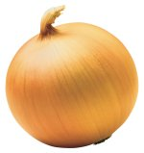

¹/₄ of the vegetables are carrots.
²/₅ are broccoli.
³/₁₀ are beans.
The rest are onions.

How many kg of each kind of vegetable are ordered?

Carrots

Broccoli

Beans

Onions

What fraction are onions?

