Vegetable Variety

Grey Gables Hotel orders 20 kg of vegetables.

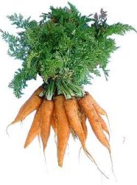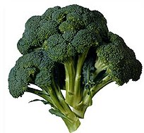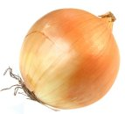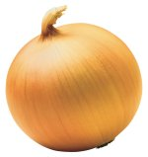

¹/₄ of the vegetables are carrots.
²/₅ are broccoli.
The rest are onions.

How many kg of each kind of vegetable are ordered?

Carrots

Broccoli

Onions

