Fast Food

A group of friends went to Macdonalds.
They only bought pizzas and coke.

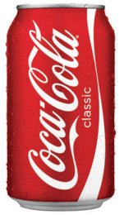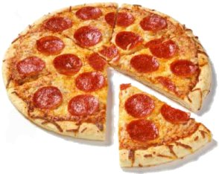
A can of coke costs 60p A pizza costs £1.50

The bill came to £8.70

How many cokes and pizzas might they have bought?

