Fast Food

A group of friends went to Macdonalds.
They only bought coca-colas and ice creams.

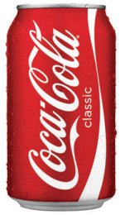
A can of coke costs 60p An ice cream costs 40p

The bill came to £3.00.

How many cokes and ice-creams might they have bought?

