The Witch's Spell

The wicked witch has lost her spell book.
She needs a spell of 20 legs.

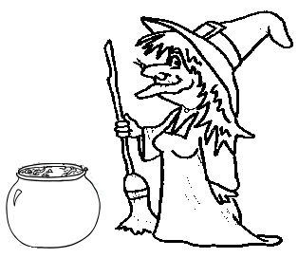

In her larder she has spiders (which have 8 legs), frogs (4 legs) and bats (2 legs).

Without cutting up any of the animals, how many different spells could she make?

