Weighty matters

Here is a set of weights:
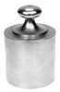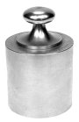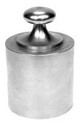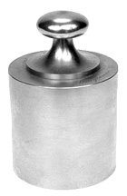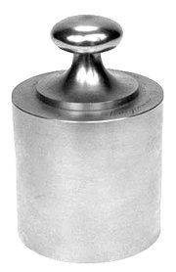

10g 20g 20g 50g 100g 200g 200g 500g 1 kg

Which would you use to measure

270g

480g

640g

890g

1.25 kg

1.4 kg

How many different ways are there of making 1.1 kg?

