Thirsty Work!

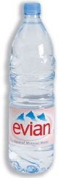

2 cartons of orange juice cost £1.16.
How much would 3 cost?
3 bottles of mineral water cost £1.35.
How much would 5 cost?
What would a carton of orange and 4 bottles of mineral water cost altogether?
How many bottles of mineral water could you buy with £4?

