Digging deep
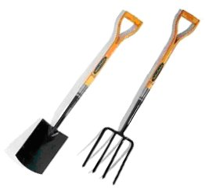

John buys a spade and fork. He pays with a £20 note and receives £4.50 in change.

The spade costs £1.50 more than the fork.

How much does the fork cost?

How much does the spade cost?

