Santa’s selection

Oh dear! Santa’s big sleigh is broken. He has to use the reserve sleigh, which only needs 3 reindeer to pull it.

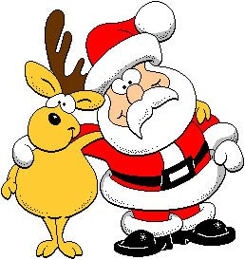

Some of his reindeer have bad colds, but Rudolph, Dasher, Dancer, Comet and Prancer are fit and ready to go.

How many different combinations of reindeer could he choose?

