Pottering on

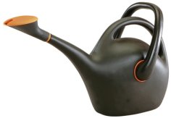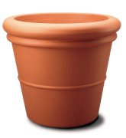

Mary buys a watering can and three flower pots.
She pays £5.00.

A watering can and one flower pot would cost £3.60.

How much will Eric pay for a watering can?

