Drawing tools

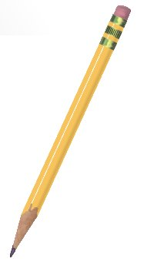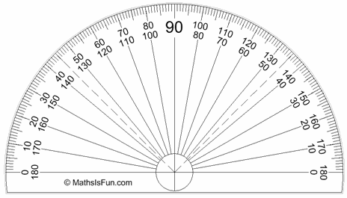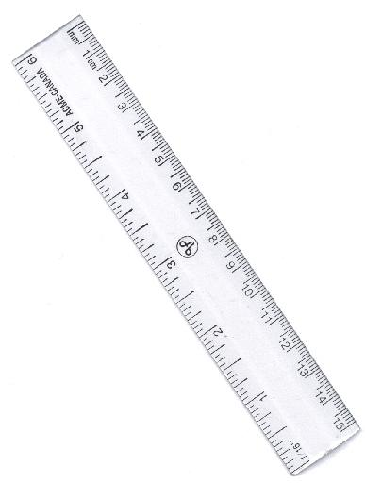

Jack buys a pencil and two rulers. He pays 60p.

Charlie buys three pencils. He pays 72p.

James buys a pencil, a ruler and a protractor. He pays 74p.

How much would Lydia pay for two pencils and a protractor?

