A Pear Tree puzzle

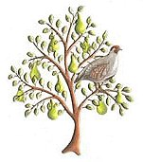

How many presents did I receive on the seventh day of Christmas?

With the previous six days, how many presents had I received altogether by then?

Which present had I received most of, and how many of them had I got?

On the seventh day of Christmas,
my true love sent to me
Seven swans a-swimming,
Six geese a-laying,
Five gold rings,
Four calling birds,
Three French hens,
Two turtle doves,
And a partridge in a pear tree.

