Serious about cereals

Muesli is sold in 750g boxes.
Porridge oats is sold in 500g boxes.

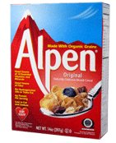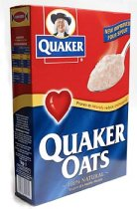

Mrs MacDougall buys 2.5 kg of cereals.
What might she have bought?

The following week, Mrs MacDougall buys 4kg of cereals.
What might she have bought?

