Big Cats

There are lions, leopards and pumas in the wildlife reserve.

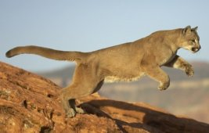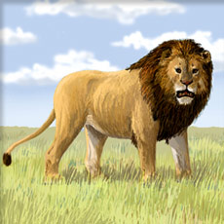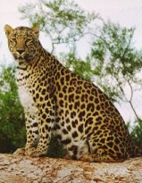

There are 36 big cats altogether.
²/₃ of them are leopards and 9 are pumas. The others are lions.

How many leopards are in the reserve?

How many lions are in the reserve?

What fraction of the animals are lions?

What fraction of the animals are pumas?

