Vegetable Variety 1

Last week, Grey Gables Hotel ordered 36 kg of vegetables.

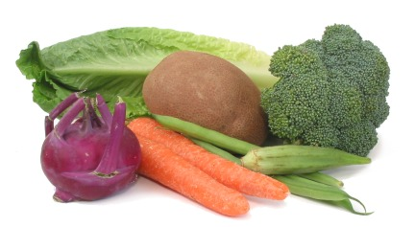
¹/₃ of the vegetables were carrots.
¹/₄ were broccoli.
¹/₆ were beans.
The rest were onions.

How many kg of each kind of vegetable were ordered?
Carrots

Broccoli

Beans

Onions

