The Safari Park

There are zebras, giraffes and antelopes in the safari park.

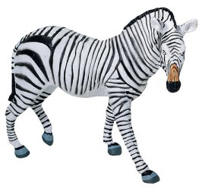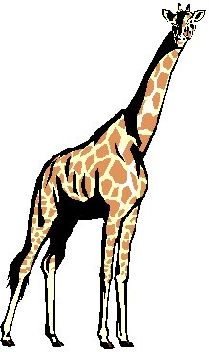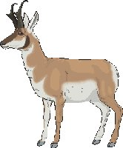

There are 48 animals altogether.
³/₈ of them are zebras and there are 8 giraffes.

How many zebras are in the park?

How many antelopes are in the park?

What fraction of the animals are giraffes?

