Small Pets

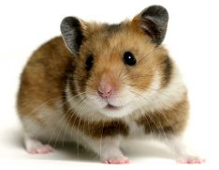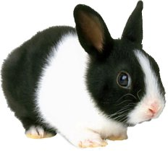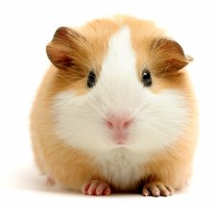

The Pet Shop has 27 small animals for sale.

There are three more guinea-pigs than rabbits.

There are twice as many hamsters as rabbits.

How many rabbits are there?

How many guinea-pigs are there?

How many hamsters are there?

