Ladybirds – 4 spots and 7
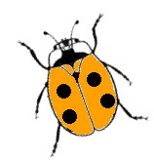
The greenfly on Mr Flowerdew's roses are being eaten by ladybirds. He is very pleased! He has noticed both 7-spotted and 4-spotted ladybirds in his garden.

One day, he counts their spots. Altogether, they have 60 spots. How many 7-spotted and how many 4-spotted ladybirds could there be that day?

