Heads and tails

Frank has a 10p coin and Rebecca has a 50p coin.
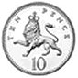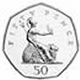

They each spin their coin to see if it lands heads or tails.
In what different ways could the two coins land?

What is the probability of 2 heads?

What is the probability of 1 head and 1 tail?

James joins in the investigation with his 20p coin.


What possible ways could the 3 coins land in now?

What is the probability of 2 heads and 1 tail?

What is the probability of 3 tails?

