Cakes for sale!

Becky and Lydia are helping on the PTFA cake stall.
The price of a chocolate cake is 40p.
The price of a fruit cake is 50p.
The price of a cream cake is 60p.

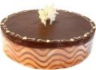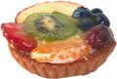

Becky’s first order adds up to £1.70.
What cakes might she have sold?

Lydia’s first order totals £1.90.
What cakes could she have sold?

