Two wheels or four?

There are 28 children in Class 3
They all have a bicycle or scooter.
³/₄ of them have a bicycle.
¹/₂ of them have a scooter.

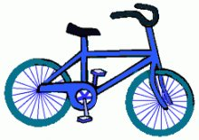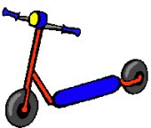

How many children have a bicycle?

How many children have a scooter?

How many children have both a bicycle and scooter?

What fraction of the children have both?

