Highlights and glitter

Jennifer went into a stationery shop. Her dad gave her £5 to spend.

She wanted to buy some highlighters costing 30p each and glitter pens at 25p each.

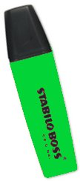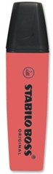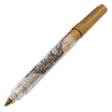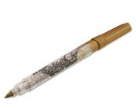

She bought three times as many highlighters as pens and was given 40p change.

How many of each did Jennifer buy?

