On Saturday 14th May, we held our annual may fair {part 1!!!} in Loders village hall.

At 2:00 Mr.Kite welcomed everyone who was at the fair.
At 2:30 the may queen {Jasmine.w} and her attendants {Jemma, charlotte, Alfie and Scott} walked to the stage and got Jasmine crowned. As soon as we got onto the stage Mr. Foot took the crown of the cushion and crowned the may queen.
After he crowned the May queen, Mr.Kite held the microphone as Jasmine said her speech.
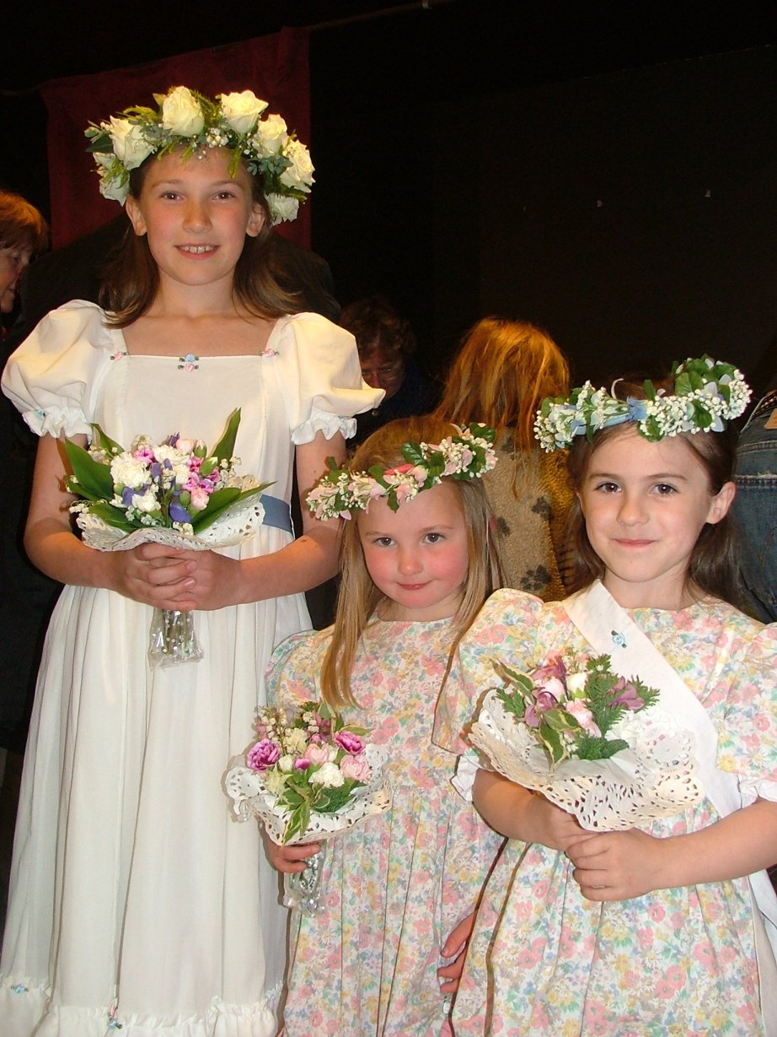After she had finished Mr.Kite opened the fair.
There where lot’s of different stalls such as teas, cakes, tombolors, Jolly Jars, Plants,
Bric-a-brac, the raffle and lots more!!!
The prizes on the stalls were sold out very quickly.
Most people were very proud what they had won!!!!!!

It was a great success and we all hope that it is a sunny day on Friday for the may queen and her attendants!!!

By Jasmine and Selena
